1. how to increase signal capacity other than bandwidth.

To increase signal capacity without adding more bandwidth, several advanced techniques can be used. These include using higher-order modulation schemes like 64-QAM, MIMO technology with multiple antennas, adding more small cells to the network, and better managing interference with methods like Coordinated Multi-Point (CoMP). Other strategies include efficient spectrum sharing, using full-duplex communication for simultaneous sending and receiving, and advanced coding techniques like Turbo codes and LDPC. These methods make better use of the existing spectrum and improve network efficiency and reliability​

2) SINR in 16 QAM graph for sender, receiver, error, no error

3) Compare reuse of 3 with reuse of 9 in terms of capacity (data rate) and quality error rate. ( I think the numbers were changed, but concept will be same.)

Reuse Factor 3:

Capacity (Data Rate): Higher due to more frequent frequency reuse.

Quality (Error Rate): Lower due to increased interference and lower SINR.

Reuse Factor 9:

Capacity (Data Rate): Lower due to less frequent frequency reuse.

Quality (Error Rate): Higher due to reduced interference and higher SINR.

4) Narrow Spectrum.

Narrow Spectrum refers to the transmission of signals over a small, specific range of frequencies. Unlike spread spectrum techniques that use a wide range of frequencies to transmit data, narrow spectrum signals occupy a limited bandwidth. Because it only uses a small part of the frequency range, it can be disrupted by other signals using the same or nearby frequencies and needs careful coordination to work well.

5) RTS CTS diagram.

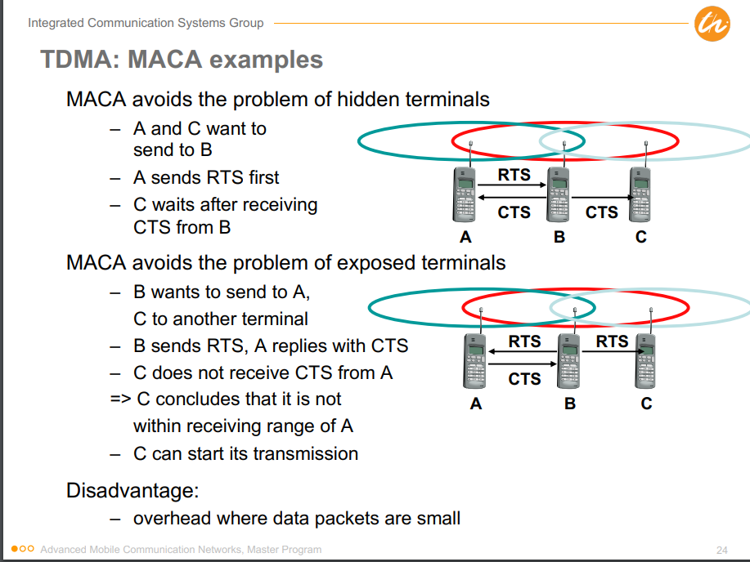

6) NAV:

The NAV (Network Allocation Vector) helps coordinate access to the wireless medium, ensuring that transmissions are orderly and reducing the likelihood of collisions by informing stations when the medium will be occupied. It tells other devices how long the network will be busy, so they wait until it's free, which prevents collisions and keeps transmissions smooth and organized.

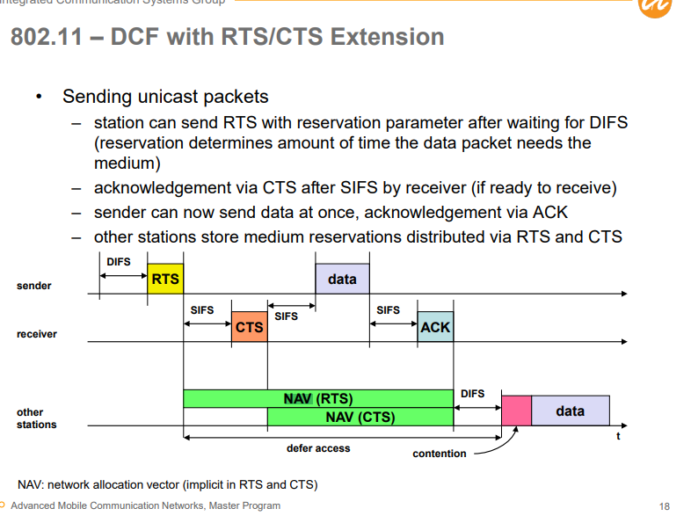

7) PCF VS FCP advantage

8) Power Management. How power management is managed in Adhoc?

9) Terminal problem with RTS and CTS. three points were given A B C And one arrow was given which helped to identify type of diagram it was.

It was Hidden. Also prepare Exposed and Near far.

10) FDD and TDD question was given which was asked w.r.t to Uplink and Downlink concept.

11) PROS of TDD (Prepare FDD VS TDD with pros and cons for both)

12) Centralized and Decentralized

13) Challenges in CDMA which are not in TDMA and FDMA

14) Self Organization properties, with respect to centralized.

15) Software Defined radio and what are the disadvantages.

16) 3 Examples of Self Organization and explain the mechanism.

17) DCF

18) Edge of Chaos.

19) Usage of proactive and reactive. Proactive Pros.

20) RREP initiated?

21) What are the advantages of Cooperate sensing?

22) Underlay and Overlay. Both are important. In paper Underlay concept was asked.

23) Prepare both soft handover and hard handover.

24) Make-before-break was asked. But prepare make-after-break as well.

25) What is spatial reuse.

26) trade off between latency, reliability one more point which I unfortunately don't remember anymore.

27) Triangle routing high latency and network load (I don't remember the question)

28) Macro and Micro ( a question was asked in which Macro concept was mixed)

29) Why TCP is reliable?

30) Incorrect TCP congestion detection.

31) Head of line blocking

32) QOS attributes (Important asked in previous exams also)

* **Data rate (throughput)**
* **Error rate (packet loss)**
* **Delay (latency)**
* **Delay variation (jitter)**

These attributes are essential for ensuring predictable service delivery to certain classes or types of traffic, independent of other factors such as other traffic or link conditions.

33) QOS strategies.

• **Reservation**:

* Reservation of "dedicated" resources for a connection (e.g., CS voice, IntServ/RSVP).

• **Differentiation**:

* Prioritization of the use of a shared resource by different connections (e.g., DiffServ).

• **Overprovisioning**:

* Dimensioning of the network such that all offered (or accepted) traffic can be handled.

34) RED VS WRED

35) mobility management within same IP sub net

If the old as well as the new AP belong to the same subnet, the problem is handled locally in the IP subnet

Link (and PHY) layer mobility management is responsible for the establishment of a radio link between the Mobile Node (MN) and the new Access Point (AP)

36) Diagram of reverse tunneling. Also, prepare diagram of tunneling. Draw CN and MN communication and show reverse tunneling.

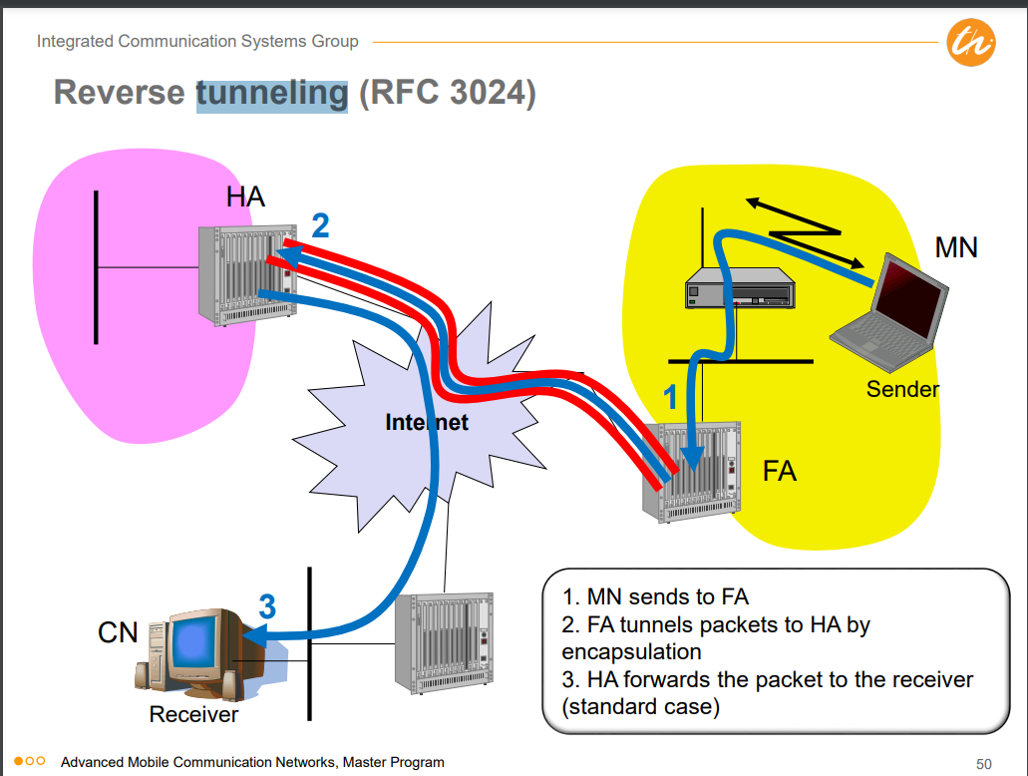

37) PCF DCF

**DCF (Distributed Coordination Function)**

* **Access Method**: DFWMAC-DCF CSMA/CA (Carrier Sense Multiple Access with Collision Avoidance)
* **Traffic Service**: Asynchronous Data Service (mandatory)
* **Collision Avoidance**: Uses a randomized "back-off" mechanism to avoid collisions

### PCF (Point Coordination Function)

* **Traffic Service**: Time-Bounded Service (optional)
* **Access Method**: DFWMAC-PCF
* **Polling Mechanism**: Access point polls terminals according to a list
* **SuperFrame**: Defines time span for polling all wireless stations by AP, including time for responses
* **QoS Limitations**: No QoS guarantees due to unknown transmission durations of polled stations and unpredictable beacon delays

38) TCP ports. Also prepare why different from IP, what are limitations, Pros, cons, when to use.

39) How to determine TCP congestion?

TCP determines congestion primarily by assuming packet loss indicates congestion, which can be problematic in wireless networks due to transmission errors and mobility issues.

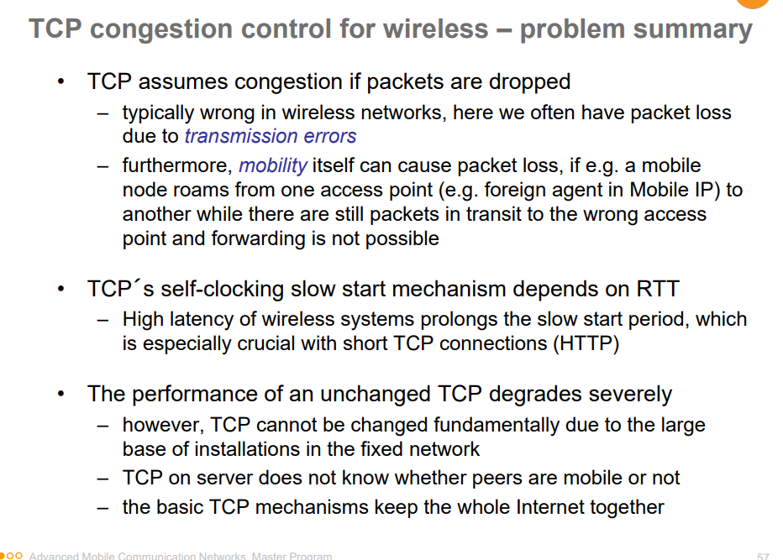

40) Qos of a wireless. (not 100% if this question was given, but I feel so. )

41) Geographical greedy based algorithm.

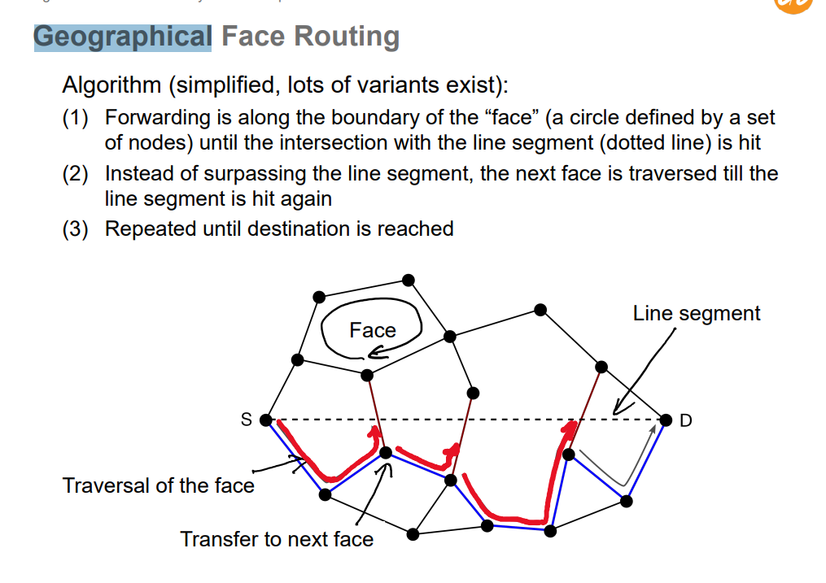

42) Challenges of spectrum sensing.

Secondary user can only sense the primary transmitters, while interference occurs at the primary receiver (hidden-terminal problem)